**SQL PROJECT OF CUTOMER BASED SALES**

**Database link-**

1. Average Purchase Amount by Category

Quarry :-

SELECT category, **AVG** (purchase_amount) AS Avg_PurchaseAmount

FROM SHOPPING

GROUP BY Category;

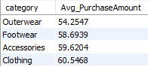Result:

2. Gender-Based Purchase Analysis

Quarry :-

SELECT gender, **COUNT**(customer_id) AS purchase_count, AVG(purchase_amount) AS AvgPurchaseAmount

FROM SHOPPING

GROUP BY Gender;

Result:



3. #Popular Items and Purchase Counts:

Quarry :-

SELECT Item_Purchased, **COUNT**(*) AS PurchaseCount

FROM SHOPPING

**GROUP** **BY** Item_Purchased

**ORDER** **BY** PurchaseCount DESC;

Result–

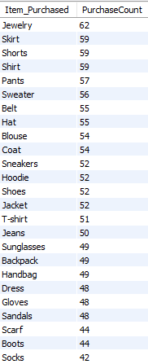

4. Popular Items TOP 5 and Purchase Counts

Quarry :-

SELECT Item_Purchased, **COUNT**(*) AS PurchaseCount

FROM SHOPPING

**GROUP** **BY** Item_Purchased

**ORDER** **BY** PurchaseCount **DESC**

limit 5;

Result

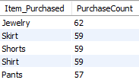

5. #Average Review Rating by Category

Quarry :-

SELECT Category, **AVG**(Review_Rating) **AS** Avg_Review_Rating

FROM SHOPPING

**GROUP** **BY** Category;

Result

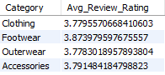

6. #Customer Subscription Analysis

Quarry :-

**SELECT subscription_status, COUNT(*) AS CustomerCount**

FROM SHOPPING

**GROUP** **BY** subscription_status;

Result



7. #Payment Method Preferences

Quarry :-

SELECT Payment_Method, **COUNT**(*) AS Payment_Method_Count

FROM SHOPPING

**GROUP BY** Payment_Method

**ORDER** **BY** Payment_Method_Count **DESC**;

Result

